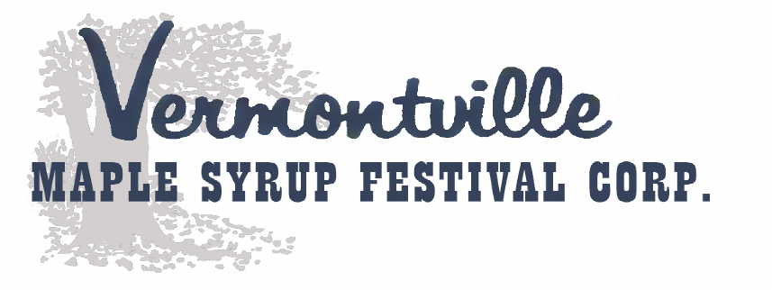
Park & Vendor Market Application
April 24th, 25th & 26th 2026

_____ Community Vendor (NO SALES - Park) _____Vendor Market (Main Street, Sales, Outdoors) _____ Food Vendor
Applicant Name: ___________________________________________________________________________________
Business Name: ____________________________________________________________________________________
Address: ___________________________________ City: ______________________ State: _______ Zip: ____________
Phone: ____________________________________ Email:__________________________________________________
Types of Items Being Sold: ____________________________________________________________________________
All spaces are 10’ x 10’. Tents, EZ Ups, tables and chairs are not provided. Vendors will be responsible for securing their areas/products as limited security will be available. No electricity or generators will be allowed unless approved by event coordinators.
Space is limited and the Vermontville Maple Syrup Festival Corporation reserves the right to accept or reject any exhibitor. *No Refunds – No Exceptions* Incomplete Applications will be REJECTED.
Prices Prior to March 31st, 2026:
10’ x 10’ @ $100.00 each # of Booths needed ____________ Total Due: _______________
Food Vendors $200.00 Space Needed: _________________ Total Due: _______________
Late Prices After April 1st, 2026:
10’ x 10’ @ $125.00 each # of Booths needed____________ Total Due: _______________
Food Vendors @ $225.00 Space Needed: _________________ Total Due: _______________
Checks or Money Orders payable to: VERMONTVILLE MAPLE SYRUP FESTIVAL CORPORATION
Please send your payment along with a self-addressed stamped envelope to:
Vermontville Maple Syrup Festival – Vendors
c/o Leslie Cook
410 South Main Street
Vermontville, MI 49096

Please contact Leslie Cook 269-816-4431 or JoDee Pruden 517-281-2807 by phone or text with any questions.
By entering The Vermontville Maple Syrup Festival on April 24, 25 & 26, 2026, you acknowledge and accept that attendance is at your own risk. The organizers, sponsors, performers, and venue are not responsible for any personal injury, illness, loss, damage, or theft of property before, during, or after the festival. This includes incidents arising from weather conditions, crowd movement, or third-party actions. The festival program, lineup, and schedule are subject to change without notice. Attendees are responsible for their own safety, belongings, and compliance with all festival rules and local laws and inspections. This disclaimer does not limit any rights you may have under applicable law.
Signature: ______________________________________________________________ Date: ________________
NOTE: This application IS NOT for the Arts & Crafts Show held at Maplewood School. If you’re interested in being located at the school, please visit our website: www.syrupfest.org for their contact information.

